**Group 7: Los Angeles Real Estate Affordability Analysis**

Arielle Williams

Kathy Castillo

Ramon Gomez

Jonathan Diaz

Michael Webb

Graduate College of Business Administration

California Polytechnic State University, Pomona

GBA 6060: Introduction to Business Analytics

Dr. Mehrad Koohikamali

December 9, 2023

**Introduction:**

The Los Angeles real estate market is known to be one of the most competitive housing markets in the US and around the world. In August 2023, the median home price in Los Angeles County was reported to be $839,780, more than double the US median home price (*Current Sales & Price Statistics*, n.d.). The high cost of real estate combined with low inventory has created a challenge for new home buyers looking to purchase in the Los Angeles metro. This housing crisis requires potential home buyers to be knowledgeable of different neighborhoods. In this project, we plan to identify the neighborhoods that are the most affordable while still providing the amenities home buyers are looking for. By investigating the factors of housing affordability and analyzing overlooked neighborhoods, we can help potential home buyers find which neighborhoods they should focus their search to better their chances of purchasing.

Many studies have examined how home prices have changed over the years, which areas are appreciating the fastest, and what demographics make up the bulk of homebuyers. For this project, we will be using the US Census, LA County government data and Zillow housing data to collect information on housing prices, income, and demographics of LA County residents. With this data, we plan to explore housing affordability within the county and analyze how that has changed over time. The research questions we will consider are:

* How have housing prices in LA County changed over the past decade?
* How has the average income of LA County residents changed over the last decade?
* How do average income and average home prices in LA County compare?
* How have the demographics of LA County changed over time?

**Problem Statement and Research Questions:**

The problem we intend to address using Business Analytics techniques is the rising unaffordability of housing in LA County. We aim to investigate and analyze the housing affordability trends in LA County over the past decade to gain a comprehensive understanding of the core affordability problem. We define affordability as the ability of individuals or households to comfortably pay housing costs, typically recommended to not exceed 30% of their income, while ensuring that the housing meets their needs in terms of quality, suitability, and considering local market conditions. To achieve this, we plan to implement descriptive analytics by examining current and historical housing data. Our goal is to identify and visualize the trends in affordability in the years 2010 and 2023, which will enable us to present a clear and data-driven picture of how housing affordability has evolved in LA County.

To augment our analysis, we'll utilize data visualization tools like GIS and Tableau, creating heat maps that depict cities in LA County based on average price growth comparisons. These visualizations will help in understanding the spatial distribution of affordability challenges.

The problem of rising unaffordability of housing in LA County has been the subject of research in previous studies. For example, a 2022 report by the LA County Department of Housing and Urban Development highlighted the increasing challenges faced by low and moderate-income households in finding affordable housing options. The report analyzed historical data on housing affordability trends and pointed to the pressing need for effective strategies to address the issue. Additionally, academic researchers have explored this problem, conducting in-depth analyses of factors contributing to housing unaffordability and proposing various policy recommendations. These existing studies underscore the importance of our research in providing a comprehensive understanding of the core affordability problem, building upon prior work and potentially offering new insights or updated data to inform policy and decision-making. We have also included additional studies in our literature review section.

Exploring the growing housing affordability crisis in LA County is crucial. First, affordable housing is a basic human necessity, and not having it can lead to social and economic problems. High housing costs can lead to housing instability and poverty, and a reduced quality of life. We hope that our analysis could provide guidance for making policy decisions, shape urban development plans, and implement specific measures to address unaffordable housing in LA County. This approach aims to create a more equitable and sustainable future for the county's residents, particularly benefiting individuals in the process of purchasing a home, ensuring that they have access to more affordable and suitable housing options.

For our analysis, we'll tap into data from various sources including government agencies like the LA County Department of Housing and Urban Development, the U.S. Census Bureau, and real estate databases such as Zillow and Redfin. These sources will offer invaluable insights into demographics, housing trends, and affordability metrics.

**Literature Review:**

While compiling the research necessary to understand the housing affordability outlook in Los Angeles County it required context from a few different domains. We first looked at a report from the Stanford Law Review on Proposition 13. They stated that initially a major roadblock occurred between the Californian citizens and state government on how to best tax land use and fiscal policy. In 1978, Proposition 13 was passed in California which meant that your property tax rate is frozen at the rate that it was purchased. This meant as your home value appreciated there was no increase in property taxes if the property isn’t sold, and the rate reevaluated for the new purchaser. Homeowners that bought in the past are not incentivized to sell if mortgage rates are high and property taxes low in comparison to “moving up” in their house. With low housing inventory and high demand prices in Los Angeles County has increased dramatically.

This ever-growing demand meant more densely populated areas with better job opportunities drove people to live farther from those areas and commute inwards. According to *Commute distance and jobs-housing fit*, on commuting it was stated that in coastal communities in California, workers commuted 10% more than the national average (Blumenberg & Siddiq, 2022). Another article, also from Blumenberg, *Housing affordability and commute distance*, stated that the commuting distance was more strongly correlated with racial and ethnic composition than it was with jobs and housing fitment (Blumenberg & Wander, 2022). This means in our research it might be helpful to see if we can show these demographics play a role in distances between densely populated areas and moving outward to less packed areas.

Another article *Rental Housing Spot Markets* which showed how rental housing data sources can be useful as a lagging metric but overall it understates the actual cost of the current market for rentals (Boeing 2020). This means we should account for housing costs to be higher than our datasets may show especially for rentals which can have a more volatile price change over time.

In the *Journal of Housing and the Built Environment,* they found that ADU’s may be affecting the market and they found that it can contribute to alleviating housing demand but there is a negative correlation with ADU’s being constructed and population density. ADU’s may be more effective in cities with less restrictive off-street parking and mostly outside or any urban core areas of LA County (Kim 2023).

While researching affordability we also found a study that looked at how mortgage lenders made their determinations for loans and compared the results between Government Supported Loans (GSE) and non-GSE loans. They found that GSE loans were more often granted better rates based on the location of the people and housing rather than their ability or history to pay (Agarwal 2023). This is helpful to know the lending landscape and that some areas may help people qualify for better interest rates without changing their current financial outlook.

Lastly, we read a few news articles and professional organization reports that discussed the current land use policies and opportunities for increased housing. Thomhave, reported in *SmartCitiesDive,* that the LA City council approved two community plans to build up to 135,000 new homes with a majority of them located in downtown Los Angeles over the next two decades. Their ultimate goal is to reach over 450,000 total new housing in the next 10 years to meet the need found in the *2022 Affordable Housing Report* which found a deficit of 499,430 homes for the lowest income earners in LA (Thomhave 2023).

This is a great initiative to combat the fact that the California Association of Realtors reported that the median housing cost in California is $843,000 which is over a 3% increase year over year. This is double the national median and in LA County is $839,780.

**Data Sources:**

To address the rising issue of housing unaffordability in LA County we will be using an LA County smoothed home value data set from Zillow. Data smoothing is a statistical technique used to reduce “noise” in a dataset. With the help of data smoothing, trends and patterns can stand out more clearly in a dataset. This data set includes variables such as: home value (month to month), city, state, county, metro, and date/year. Originally, the dataset provided a month to month smoothed home value for each zip code in Los Angeles. The home values started from the year 2000 and ended in 2023. To help with our research we simplified the data set and took the average of each year for every zip code available in Los Angeles. The home value dataset was crucial for making visualizations in Tableau and layers in ArcGIS . Our secondary datasets were brought in from ArcGIS Business Analyst for a variety of areas including income, housing, population, and race. For comparison in Tableau, we brought in data for these areas from 2010, 2023, and 2028. Using data from these years we can have a clear look at the past, present, and future of the housing market in Los Angeles County.

We have collected and researched data on housing prices, income levels, and the economic indicators in LA County from reputable sources such as Zillow and ArcGIS Business Analyst. Now that we have our datasets, we can apply descriptive statistics and data visualizations to understand housing affordability trends. We plan to use data visualization tools such as ArcGIS and Tableau. In ArcGIS we will be using a combination of heat maps along with layering tools to indicate which areas in LA County have become less/more affordable over time, and specifically determine what cities within the county.

**Data Cleaning, Modeling & Depth of Analysis:**

We realized early on that combining these datasets would be difficult because of a few key reasons. Firstly, zip code data was created for the postal service to deliver mail and is based on postal routes, not strict areal boundaries. These zip code routes also can overlap across city boundaries so there were issues where you could filter by city or zip and certain cities or zip codes disappear across year spans because of the nature of city and zip code boundary lines. We decided to use the Zillow time series data as our key for all zip codes and city boundaries unless we were looking at only a particular year set of data with no relationship to the time series data. This is so we could account for a consistent behavior for filtering and results.

Secondly, ESRI data gave us many Median Value measures which required aggregation at a city level by averaging the medians for all zip codes in a city. Occasionally, we would find discrepancies between the Zillow average price data with median or average home value data, but we tried to stay with Zillow home price data since it was already cleaned and at a finer level of granularity.

According to Zillow, the Zillow Home Value Index (ZHVI) is “A measure of the typical home value and market changes across a given region and housing type. It reflects the typical value for homes in the 35th to 65th percentile range (Zillow, 2011).” This meant it excluded many outliers for different regions which will describe the discrepancies between ESRI Home Value figures with Zillow’s. ESRI is a stricter average or median value but Zillow is more nuanced. We used both measures but tried to rely on the Zillow data most of all.

Lastly, when gathering data sources, we realized we could not get equivalent columns to compare between 2010 and 2023 data from ESRI. This posed a challenge as we could not compare measures such as median household income from 2010 at a zip or city level. We were able to find the value for LA County as a whole which we used in our final analysis but it would have been more accurate and 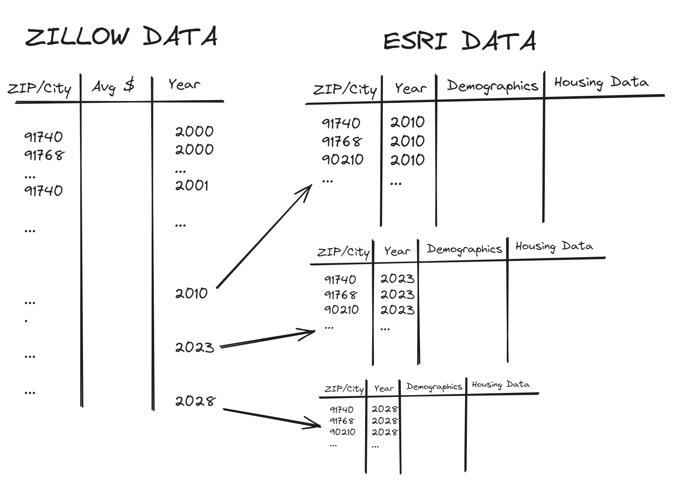insightful if we could compare the changes over time in cities.

Once we cleaned the data, we created a small relational data model. We considered this as our “Fact” table where we could join the ESRI data on the Zip Code and Year. This gave us the ability to directly compare and add data easily for analysis.

For analysis we used Tableau and ArcGIS to build exploratory tools and visualizations to uncover insights in our data. These dashboard and report building tools allowed us to visualize time series data, aggregations of home prices and demographics, GIS heatmaps using the Housing Affordability Index, and other charts for comparison.

The most helpful tool was using the affordability index values for 2023 to filter cities on time series data to see the price trends for cities that are currently within our affordability zones. We also could group these cities for further filtering and get a list of the most affordable cities in LA county along with a projection of future housing prices according to the 2028 ESRI dataset.

**Relevance and Actionability of Insights:** Who should care and why?

Addressing the recent increase in average home prices over the past few years in LA County is important because this directly affects the local population in many ways. The LA County housing issue has caused a shift in demographics, leading to a decline in the number of individuals who are capable of purchasing homes. While LA County consists of numerous cities, certain demographic regions may stand out as more desirable due to their accessibility to resources: diverse entertainment options, city resources, proximity to communities, and access to quality school districts.

Our project analysis holds significance for several key groups. Firstly, local residents and prospective homebuyers would have interest in understanding the dynamics of housing affordability, as it directly influences their ability to buy suitable housing. In addition, this analysis is important for policymakers and local government officials because the shifting demographics require them to take strategic actions to ensure individuals have fair access to housing and that the community stays diverse and prosperous. Also, community organizations and advocacy groups can leverage the insights from this analysis to advocate for policies and initiatives that address specific community needs, guiding resource allocation to areas most in need. The housing crisis in LA County is also closely linked to the problem of homelessness. According to the Homeless Crisis Report there has been a 4.1% increase from 2020 in the number of people who are experiencing homelessness. The lack of affordable housing has contributed greatly to the increase in individuals experiencing homelessness.

Furthermore, employers and businesses operating in LA County should care about this study, as housing affordability directly influences workforce demographics. Accessible housing is crucial for attracting and retaining talent, making it an essential factor in sustaining a strong local economy. Lastly, real estate developers and investors would take interest in our analysis to understand housing affordability trends to align their investments with the evolving needs of communities and market demands. In summary, this project is important for providing a comprehensive understanding of the housing landscape in LA County, and the information it provides is essential for making informed decisions and implementing effective actions involving a variety of stakeholders.”

Ultimately our aim is to create value by looking into communities in LA County that offer these resources and potential compromises to find those affordable neighborhoods. By investigating this topic we will be able to answer what neighborhoods we should prioritize for future affordable housing.

**Data Visualizations from Tableau:**

**Figure 1**

*Population Size by City*

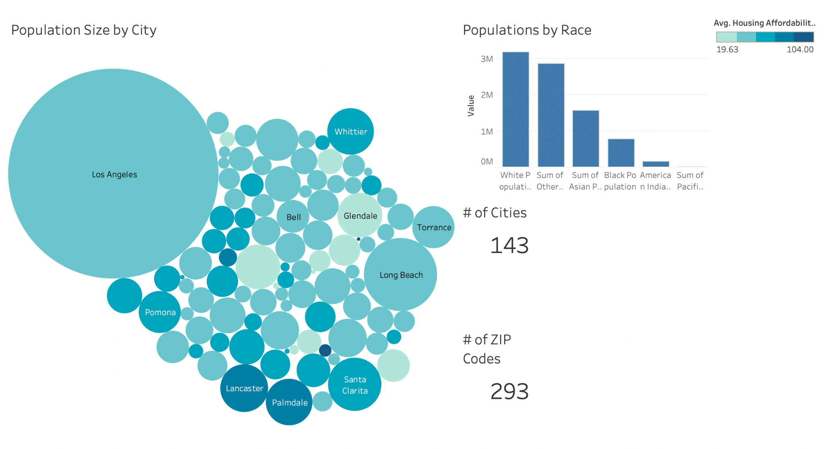

*Note.* Darker shade of blue represents a higher Affordability Index.

Los Angeles County is a large and diverse county with nearly 100 cities and over 100 unincorporated areas. As shown in the figure above, Los Angeles is the largest city in LA County with a population of 3,884,229 followed by Long Beach (470, 371). The Housing Affordability Index is also included in Figure 1. The housing affordability index measures the degree to which a typical family can afford the monthly mortgage payments. Cities such as Lancaster (87) and Palmdale (84) have a higher index than Los Angeles (37).

**Data Visualization from ARCGIS: Affordability and Diversity**

**Figure 2**

*Figure 2A. Affordability*

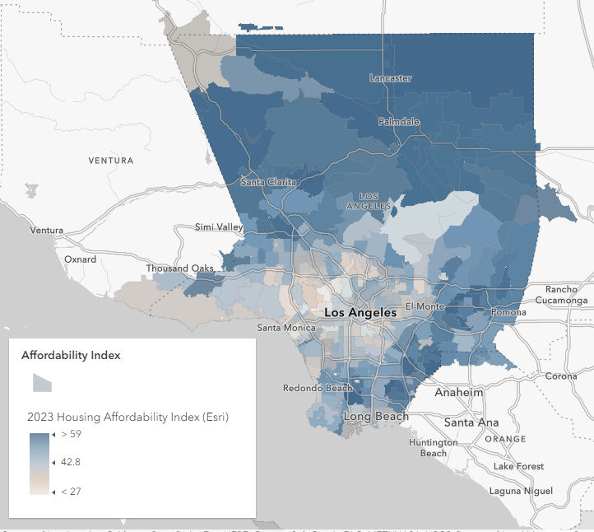

Figure 2A shows a heat map for the Housing Affordability index of Los Angeles County. The Housing Affordability index represents an area where the median income is enough to qualify for a loan and not burden the consumer. Values that are greater than 100 are indicative of increasing affordability. Areas outside of the center to the east of Los Angeles and North Los Angeles have higher Housing Affordability index numbers. Overall LA county holds a Housing Affordability Index number of 43.

*Figure 2B. Diversity*

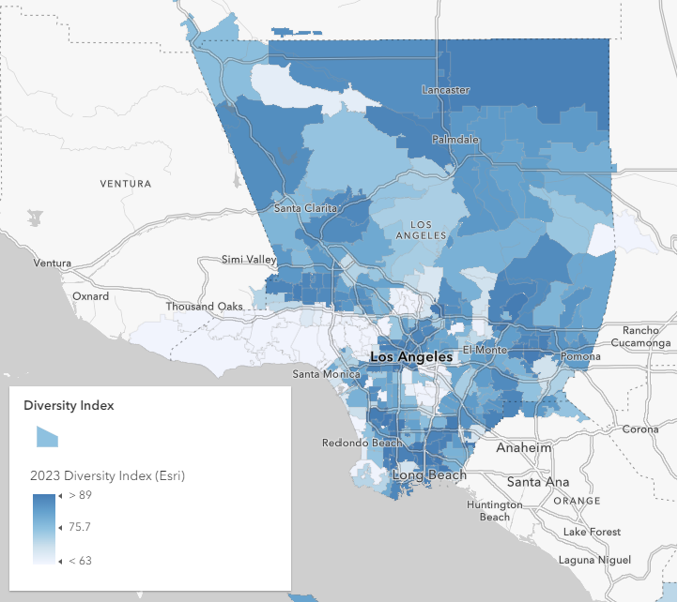

Figure 2B shows a heat map for the Diversity index of Los Angeles County. The index displays the likelihood that two people from the same area belong to a different race. From the heat map we can see there are many pockets with high diversity. Lancaster and Palmdale have some of the highest diversity indexes in the North. While the center and south of LA have many pockets with mid to high numbers of diversity, Overall LA county has a diversity index number of 88.

**Data Visualization from Tableau:**

**Figure 3**

*2010 Housing Prices by City vs 2023 Housing Prices by City*

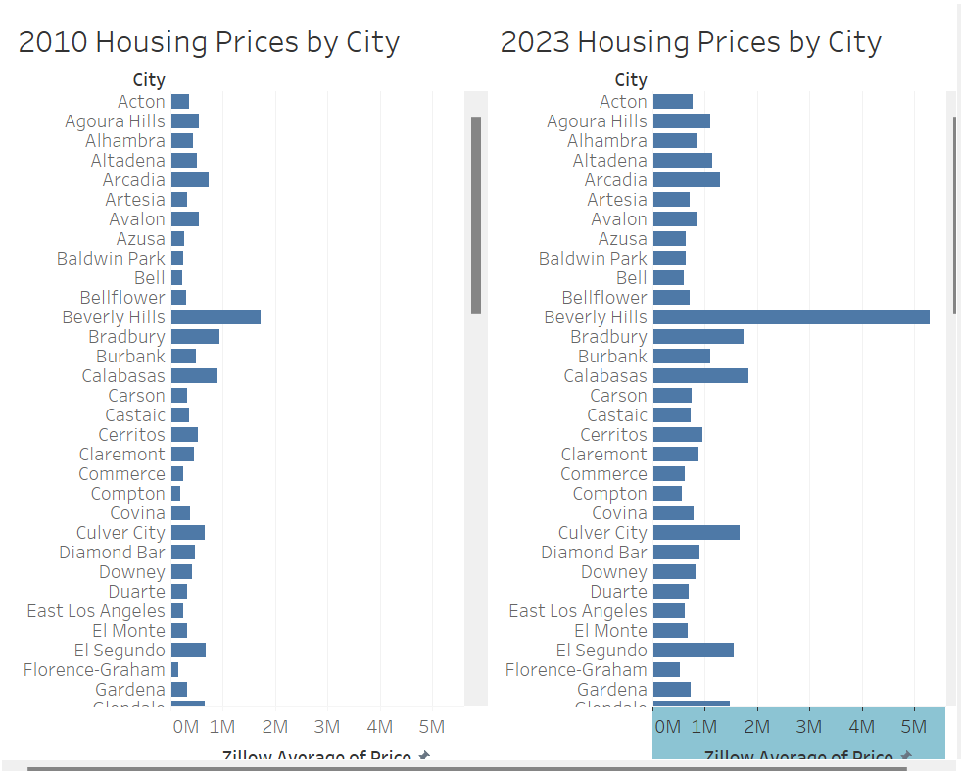

**Additional view:**

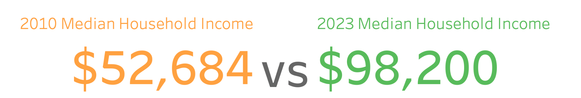

This Tableau visualization consists of two bar charts, illustrating the evolution of housing prices in Los Angeles County from 2010 to 2023 across various cities. The bar chart on the left displays the housing prices in 2010, while the bar chart to the right displays the corresponding information in 2023, revealing an upward trend of prices. By visually contrasting the housing prices in different cities across these two years, users can quickly identify patterns and trends, enabling them to make informed decisions about housing in the region. We also included the average median household income from 2010 vs 2023. Over this period, the average income surged from $52,684 to $98,200, reflecting a substantial percentage increase.

**Figure 4**

*Average House Price Time Series Analysis*

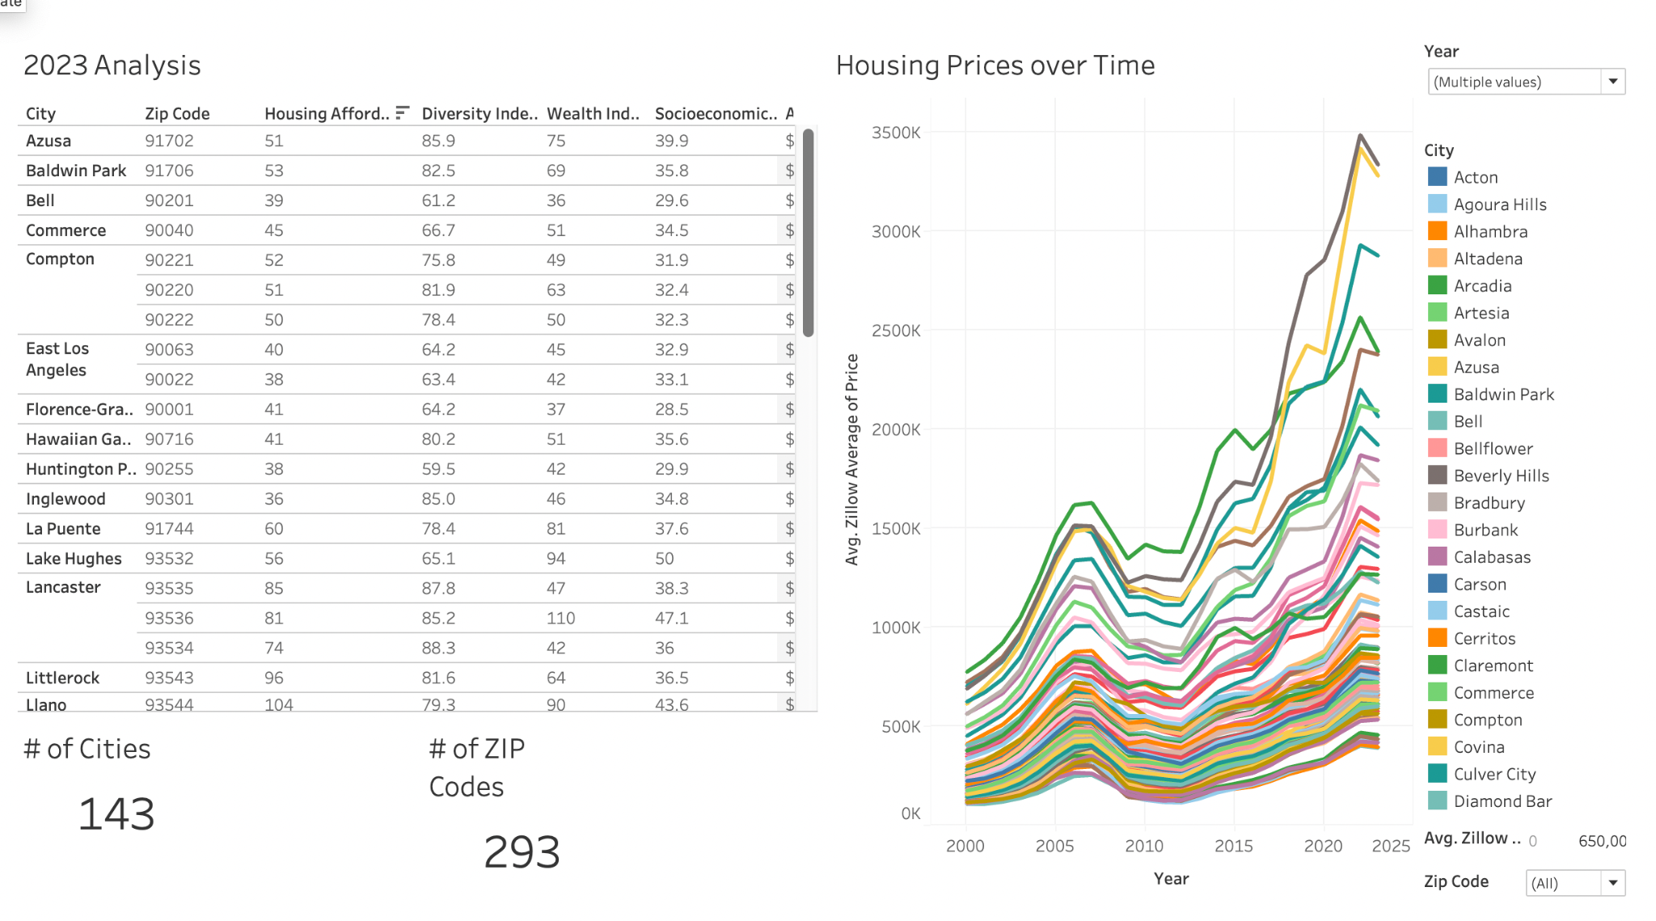

**Additional Views:**

*Avg Prices Over Time (Temporal)*

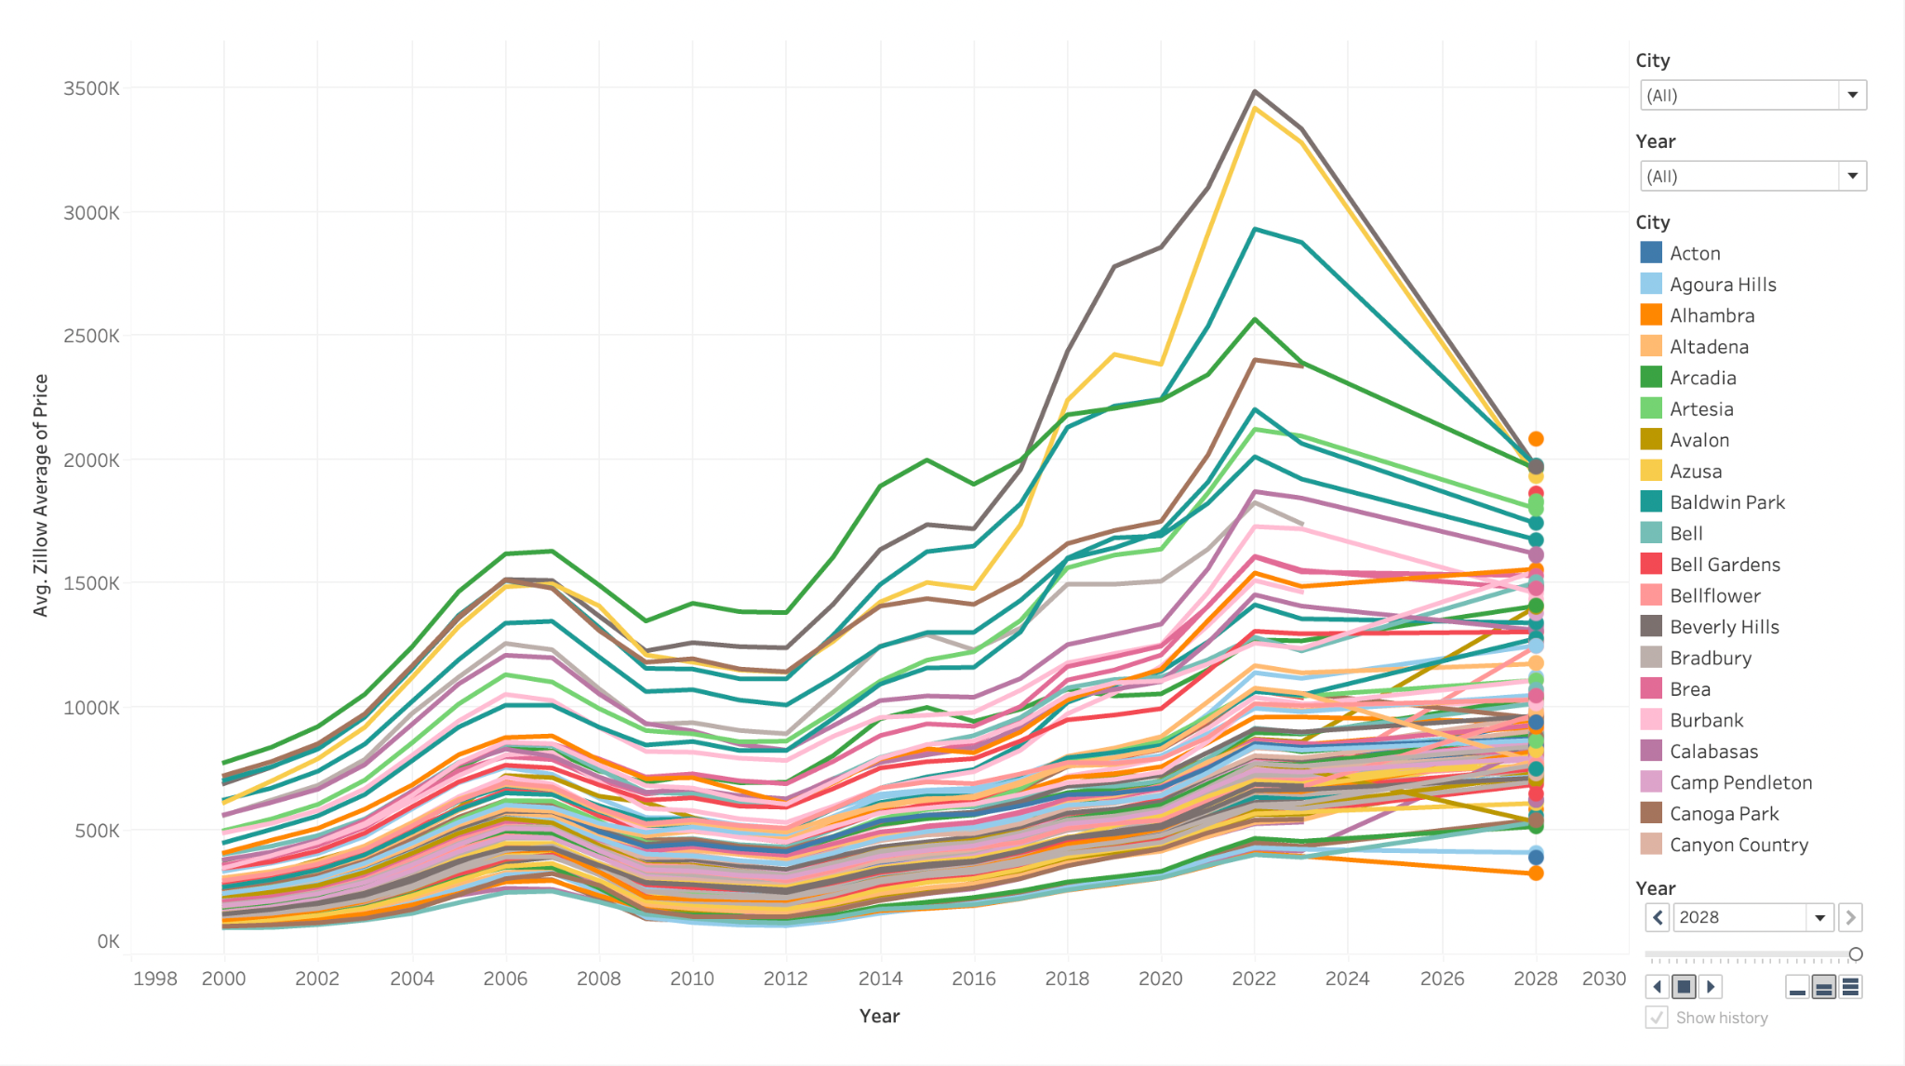

*Price Trend Breakdowns by Pomona Area*

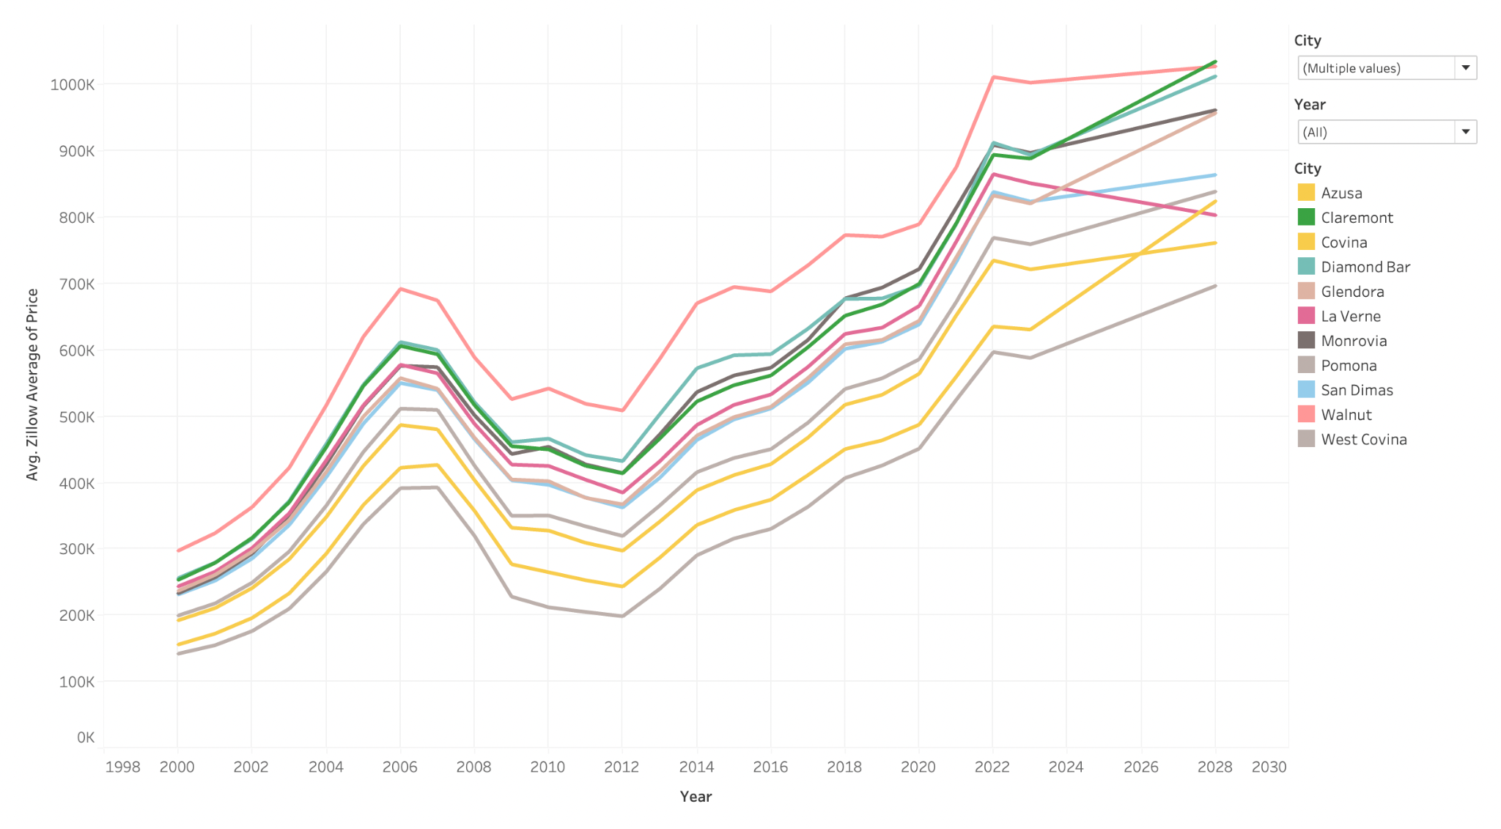

These visualizations include a table with information on each city which includes average home value, total housing units, and housing affordability index. Along with this table it also includes a graph of average Zillow house prices from 2000 to 2028. The table and graph are controlled with a filter for city, year and housing affordability index. By filtering for the Housing Affordability index, we can see which cities are the most affordable and what the prices are projected to be in 2028.

**Figure 5**

*Housing Affordability and Diversity Index*

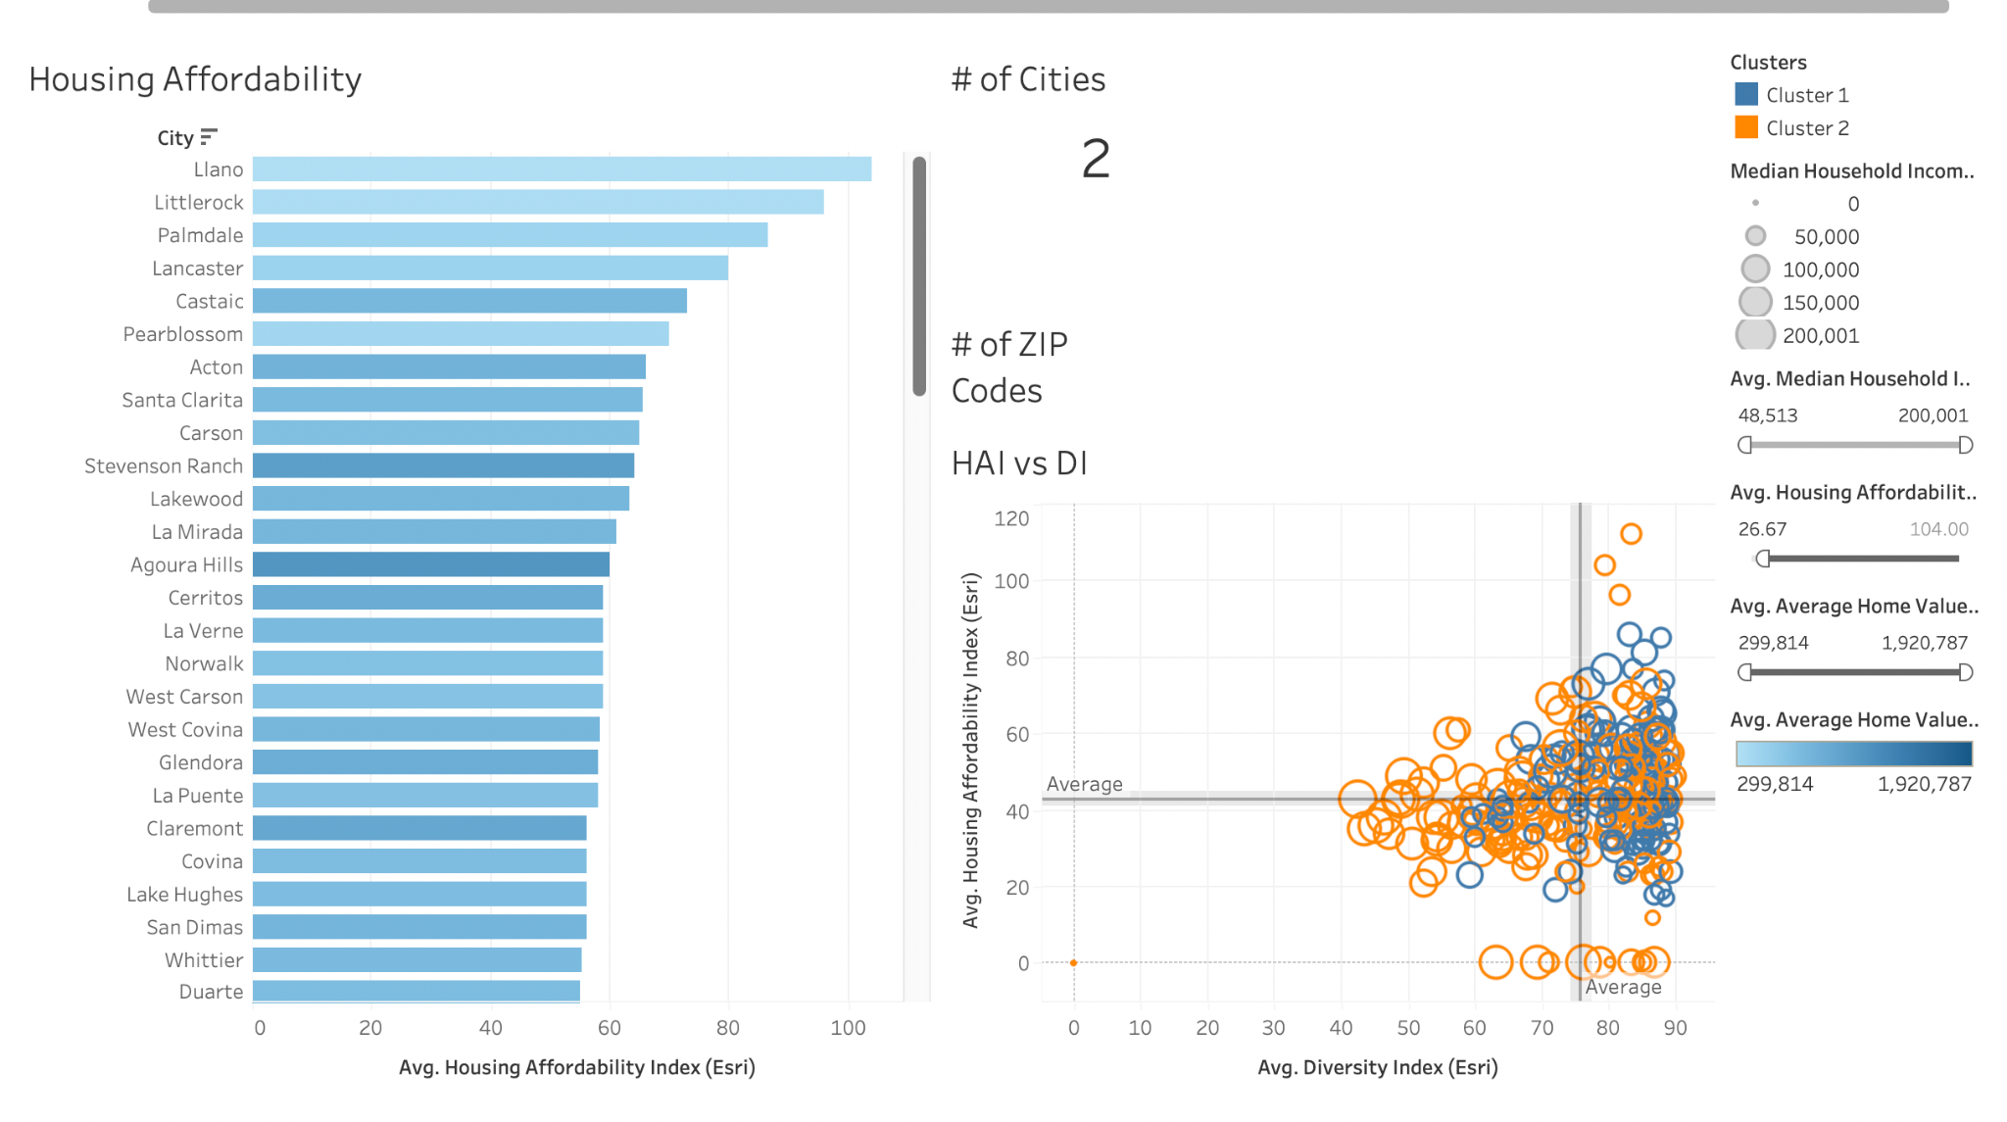

Figure 5 contains data from 2023, housing affordability and Diversity Index. According to Data USA, the median household income for LA County is about $76,000. In order to see where LA County residents are able to afford to live Figure 5 helps us identify those cities. The X- axis represents the Housing Affordability Index and the Y -axis displays the cities. The Housing Affordability index is a metric that measures whether a typical family could qualify for a mortgage on a typical loan. So the higher the value means that the city is more affordable. The slider has the range of $60,000 to $90,000, with an housing affordability index of 50 and above. There is also a third parameter that allows us to visually see what cities are more expensive. The darker shade of blue indicates that the average home value is more than those cities in the lighter shade of blue.

The 2023 HAI vs DIV index figure shows the housing affordability index and diversity index for LA county grouped into two clusters. Cluster 1 contains cities with a higher diversity index and higher housing affordability. While cluster 2 shows the cities with lower diversity index and lower housing affordability index.

**Conclusion and Recommendations:**

In conclusion, utilizing BI tools such as ArcGIS and Tableau have made it much easier to understand how housing affordability has changed in LA county over the past decade. The visualizations presented in Figures 1 to 5 have provided valuable insights into various aspects of our research questions. Figure 1 highlights the population distribution by city, setting the stage for understanding the demographic landscape. Figures 2A and 2B from ARCGIS offer a comprehensive view of the county's landscape in 2010 and 2023, aiding our analysis of geographical trends in housing affordability.

In addition, some of the most insightful visualizations can be found in Figure 3, Figure 4, and Figure 5, created with Tableau. Figure 4 emerges as a crucial visualization, allowing users to filter 2023 data in the 2000-2023 time series visualization. This dynamic time series visualization provides a comprehensive view of average housing prices in LA County from 2000 to 2023, offering an understanding of historical trends and a glimpse into the projected average housing price in 2028. Figure 3's bar charts effectively showcase the change in housing prices from 2010 to 2023, illustrating a notable upward trajectory. This visual representation is crucial for grasping the overall trend and variations across different cities. Figure 5, the Housing Affordability and Diversity Index, serves as a powerful tool for identifying cities where residents can afford to live based on median household income. The clusters generated by this visualization provide a greater understanding of the relationship between housing affordability and diversity in different cities.

Addressing our research question of how housing prices have changed over the past decade, we observed an upward trend from 2010 to 2023, projecting a continued trajectory into 2028. Notably, some areas exhibited projected housing prices with a downward trend, emphasizing how diverse the real estate landscape is in LA county.

Our second research question was answered through analyzing income data from 2010 to 2023 using BI tools as it revealed an upward trend in the average income of LA County residents. Over this period, the average income surged from $52,684 to $98,200, reflecting a substantial percentage increase. This positive increase is likely caused by various economic factors, including inflation and shifts in the job market.

To answer our third research question, we examined data from 2010 to 2023 and utilized BI tools to identify relationships between average income and home prices in LA County. Areas with higher average incomes tend to experience higher home prices, and vice versa. This can be influenced by factors such as the local job market, economic conditions, demand for housing, and the overall cost of living. Further research would need to be explored.

To answer our final research question, we explored demographic data from 2010 to 2023, and we discovered that many factors can influence demographic shifts. For example, economic shifts, changes in job markets, and variations in housing costs may contribute to demographic movements, potentially influencing the composition of residents in different areas within the county. Additionally, shifts in population density and the attractiveness of certain neighborhoods due to affordability factors may play a role in shaping the demographic landscape over the years. However, further research is imperative to understand how these factors contribute to the observed trends.

Moving forward, we recommend further research to explore the specific factors contributing to the observed trends. Exploring the impact of local policies, economic developments, and demographic shifts on housing affordability could provide a more granular understanding. Additionally, continuous monitoring and updating of these visualizations would ensure that stakeholders are equipped with the most current and relevant information for decision-making.

Our project offers a practical tool for a diverse audience, including policymakers, local government officials, real estate developers, and potential homebuyers. The user-friendly visualizations empower individuals to navigate the complex housing landscape, aiding informed decision-making in a competitive market.

**References**

*2022 Affordable Housing Report – Homeless Initiative*. (2022). Homeless.lacounty.gov. <https://homeless.lacounty.gov/news/2022-affordable-housing-report/>

Agarwal, S., Deng, Y., He, J., Wang, Y., & Zhang, Q. (2023). Lenders’ pricing strategy: Do neighborhood risks matter? Real Estate Economics, 51(4), 1011–1047. <https://doi-org.proxy.library.cpp.edu/10.1111/1540-6229.12421>

Blumenberg, E., & Siddiq, F. (2022). Commute distance and jobs-housing fit. *Transportation*, *50*. <https://doi.org/10.1007/s11116-022-10264-1>

Blumenberg, E., & Wander, M. (2022). Housing affordability and commute distance. *Urban Geography*, *44*(7), 1454–1473. <https://doi.org/10.1080/02723638.2022.2087319>

Boeing, G., Wegmann, J., & Jiao, J. (2020). Rental Housing Spot Markets: How Online Information Exchanges Can Supplement Transacted-Rents Data. Cornell University Library, arXiv.org. <https://doi.org/10.1177/0739456X20904435>

*Current Sales & Price Statistics*. (n.d.). Www.car.org. https://www.car.org/en/marketdata/data/countysalesactivity

Danforth, E. (2021). Proposition 13, Revisited. *Stanford Law Review*, *73*(2), 511–553. <http://proxy.library.cpp.edu/login?url=https://www.proquest.com/scholarly-journals/proposition-13-revisited/docview/2501927576/se-2>

Franchino, N. (2023, January 11). La County Census Tracts (by Supervisorial District, planning area and community). LA County Census Tracts (by Supervisorial District, Planning Area and Community) - County of Los Angeles Open Data. <https://data.lacounty.gov/datasets/la-county-census-tracts-by-supervisorial-district-planning-area-and-community>.

Johnson, H. (n.d.). *Large Cities Lose Population even as They Add New Housing*. Public Policy Institute of California. <https://www.ppic.org/blog/large-cities-lose-population-even-as-they-add-new-housing/>

Kim, D., Baek, S.-R., Garcia, B., Vo, T., & Wen, F. (2023). The influence of accessory dwelling unit (ADU) policy on the contributing factors to ADU development: an assessment of the city of Los Angeles. *Journal of Housing and the Built Environment*, *38*(3), 1585–1599. <https://doi.org/10.1007/s10901-022-10000-2>

Monkkonen, P., Manville, M., Lens, M., Barrall, A., & Arena, O. (2023). California’s Strengthened Housing Element Law: Early Evidence on Higher Housing Targets and Rezoning. Cityscape, 25(2), 119–142. <https://www.jstor.org/stable/48736624>

Porter, T. J. (2023, October 6). *California Housing Market: Everything you need to know*. Bankrate. <https://www.bankrate.com/real-estate/housing-market/california/#housing-market>

Thomhave, K. (2023, June 12). *Land-use reform efforts could bring 135K new homes to downtown Los Angeles, Hollywood*. Smart Cities Dive. <https://www.smartcitiesdive.com/news/land-use-reform-los-angeles-affordable-housing-new-homes/652671/>

Zillow. (2011). Housing Data - Zillow Research. Retrieved from Zillow Research website: https://www.zillow.com/research/data/

**Appendix**

**Appendix A**

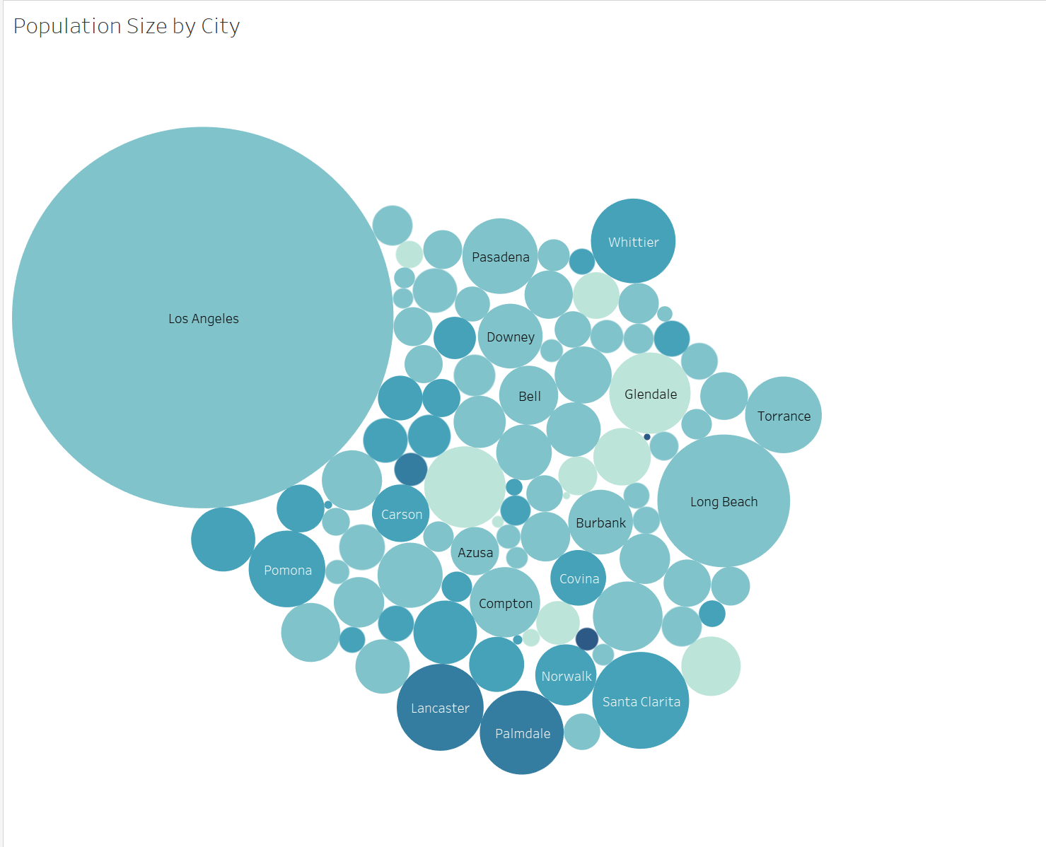

**Appendix B**



**Appendix C** 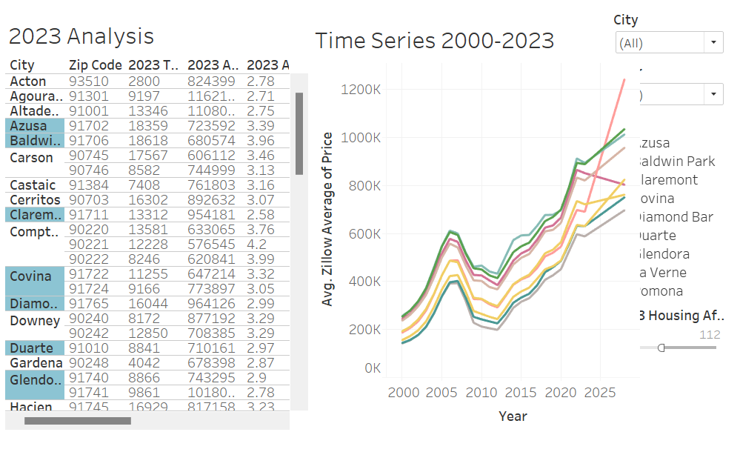

**Appendix D**



**Appendix E**

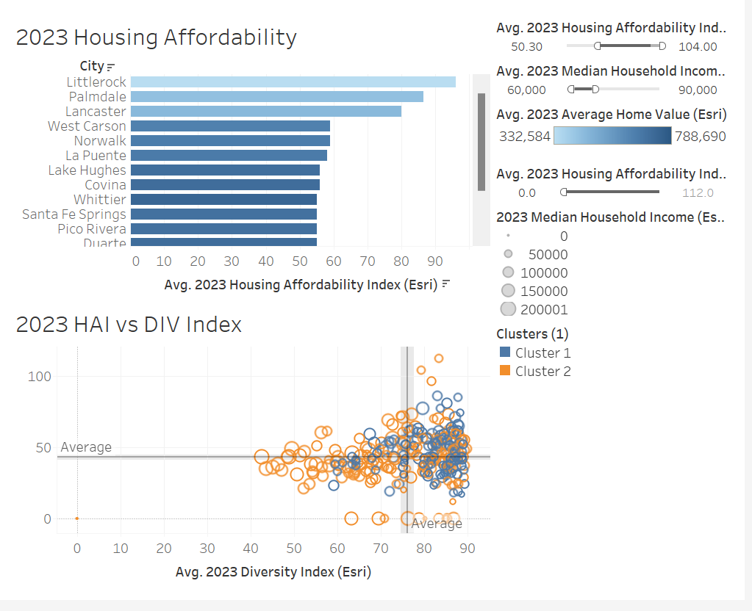

**Report Requirements:**

Write a comprehensive report detailing your methodology, analysis, and recommendations. Report should be 10-15 pages, double-spaced, font size 11. References, charts, maps, and visualizations are excluded from the page count.

**Evaluation of Criteria:**

1. **Quality of Data Visualization (data reliability, data transparency, data applicability)** – 20%
2. **Depth of Analysis (alignment of analysis methods and research questions)** – 20%
3. **Relevance and Actionability of Insights** (so what question! Who should care and why?) – 20%
4. **Quality of Report and Presentation** (even though this class is introductory I would be very focused on your story telling approach and how your present your findings and visuals, report also has to be clean of grammatical issues and proofread – make it one consistent format that would be seen as a professional report of your work, use Chat GPT or other AI tools as your assistant, but do not copy and paste – improve the content you write, not the AI tool content) – 40%